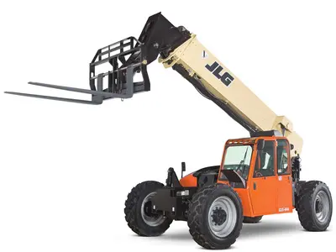
JLG G15-44A

- Axle-Front: High Bias, Limited Slip
- Axle-Rear: Planetary
- Capacity – Fuel Tank: 38 gal. / 143.85 L
- Drawbar Pull: 24000 lb / 10886.22 kg
- Engine Horsepower: 130 hp / 96.98 kW
- Engine Manufacturer: Cummins
- Engine Model: QSB4.5L ATAAC Tier 4 Interim
- Frame Leveling: 10 Degrees
- Function Pump Type: Load Sensing Piston
- Ground Clearance: 1 ft 6 in. / 0.46 m
- Lift Capacity at Full Height: 7000 lb / 3175.15 kg
- Lift Capacity at Max Reach (Stabs Up): 2000 lb / 907.18 kg
- Load Center: 2 ft / 0.61 m
- Machine Height: 8 ft 5 in. / 2.57 m
- Machine Length: 20 ft / 6.1 m
- Machine Width: 8 ft 5 in. / 2.57 m
- Maximum Engine RPM: 1500 rpm
- Maximum Lift Capacity: 15000 lb / 6803.89 kg
- Maximum Lift Height: 44 ft / 13.41 m
- Maximum Reach: 31 ft / 9.45 m
- Operating Vehicle Weight: 32500 lb / 14741.75 kg
- Outriggers or Stabilizers: No
- Outside Turning Radius: 14 ft 6 in. / 4.42 m
- Service Brake Type: Wet Multi-Disc
- Speed – Maximum Lift: 16 sec.
- Speed – Maximum Lower: 15 sec.
- Speed – Maximum Telescope In: 13 sec.
- Speed – Maximum Telescope Out: 17 sec.
- Speed – Maximum Travel: 20 mph / 32.19 km/h
- Tire Size: 17.5 x 25
- Transmission – Nr Forward Gears Standard: 4
- Transmission – Nr Reverse Gears: 3
- Transmission Type: Powershift
- Wheelbase: 12 ft / 3.66 m

